Bangladesh University of Engineering and Technology

Department of Computer Science and Engineering

**CSE 316 July 2022**

Microprocessors, Microcontrollers, and Embedded Systems Sessional

**Experiment 4**

**UART Communication Between ATmega32 and Arduino**

**GOAL:**

To understand the basic working principle of UART and external interrupt.

**EXPERIMENTAL TOOLS AND MATERIALS:** ATmega32, USBASP programmer, Arduino UNO, Trainer Board, Wires, LED, Push Button.

**BASIC DESCRIPTION:**

In this experiment, you will have to turn on a LED connected to Arduino UNO depending on a push button connected to Atmega32. Atmega32 will send the state of the push button to Arduino UNO using UART communication.

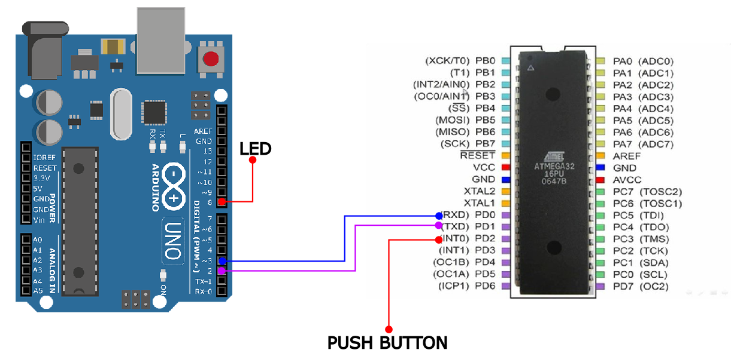

**UART (Arduino Atmega) Basics:**

Use the following code snippets for Atmega32 to send characters every 1 second.

#define F_CPU 1000000

#include <avr/io.h>

#include <util/delay.h>

void uart_init()

{

UCSRA = 0b00000010;

UCSRB = 0b00011000;

UCSRC = 0b10000110;

UBRRH = 0;

UBRRL = 12;

}

void uart_send(unsigned char data){

while ((UCSRA & (1<<UDRE)) == 0x00);

UDR = data;

}

unsigned char uart_receive(void){

while ((UCSRA & (1<<RXC)) == 0x00);

return UDR;

}

int main(void)

{

uart_init();

_delay_ms(1000);

while(1)

{

for(char c = 'a'; c <= 'z'; c++) {

uart_send(c);

_delay_ms(1000);

}

}

}

Use the following code snippet for Arduino UNO to read the characters and print them on the Serial Monitor continuously.

#include<SoftwareSerial.h>

SoftwareSerial SUART(2, 3); //RX = DPin-2; TX = DPin-3

void setup() {

Serial.begin(9600);

SUART.begin(9600);

}

void loop() {

byte n = SUART.available();

if (n != 0)

{

char x = SUART.read();

Serial.print(x);

}

}

**PROCEDURE:**

1. Establish serial communication between Atmega32 and ArduinoUNO.
2. Connect a push button to Atmega32.
3. Connect a LED to ArduinoUNO.
4. With the press of the button, send a character from Atmega32 to ArduinoUNO. You must handle button logic with an external interrupt.
5. Upon receiving the character, Arduino UNO should toggle the LED.

**MISC:**

1. You should be prepared to communicate at any baud rate assigned during the experiment.
2. Study the provided code snippets. You must be able to modify them on demand.